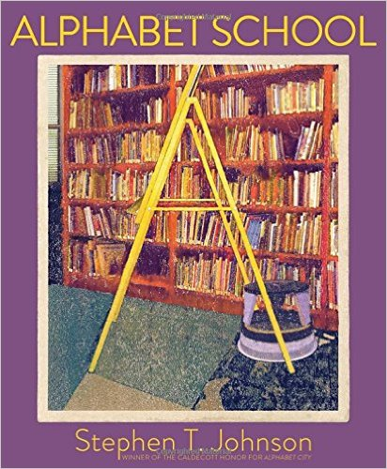 | Alphabet School, by Johnson, Stephen T.  From Follett  "A Paula Wiseman book"--Title page. Displays the alphabet in everyday objects found at school.
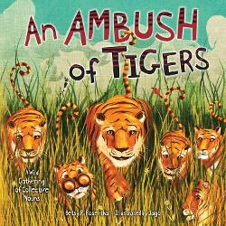 | An ambush of tigers: a wild gathering of collective nouns, By Rosenthal, Betty R  From Follett  "Have you ever heard of a prickle of porcupines? A tower of giraffes? This romp through the animal kingdom introduces collective nouns for animals through wordplay."--Publisher
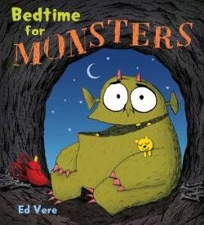 | Bedtime for Monsters, by Vere, Ed  From Follett  A hungry monster seeks a different type of bedtime snack.
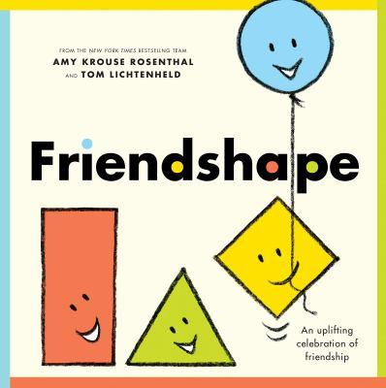 | Friendshape, by Rosenthal, Amy Krouse  From Follett  "Friends shape who we are. They make us laugh. They fill us with fun. They stand by us during life's up and downs. And even when we disagree with our friends, if they're tried-and-true, they don't stay bent out of shape for long. That's the beauty of a good buddy. This joyous book rejoices in the simple beauties of friendship"--Amazon.com.
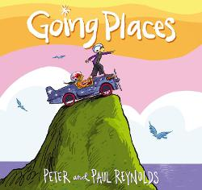  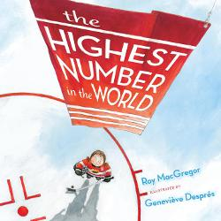 | Going Places, by Reynolds, Peter H  From Follett  Rafael has looked forward to the Going Places contest and builds his go-cart from a kit in record time, but his neighbor, Maya, has a much more interesting and creative idea for her entry and Rafael decides to help.  Highest number in the world, the, by MacGregor, Roy  From Follett  Nine-year-old Gabriella "Gabe" Murray is thrilled when she makes it on The Spirit hockey team, but is upset when she gets jersey number 9 instead of number 22, her hero's number, until her grandmother explains the importance of the number 9 in hockey history.
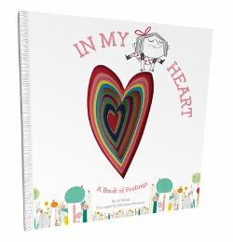 | In my heart a book of feelings, by Witek, Jo  From Follett  A young girl explores what different emotions feel like, such as happiness which makes her want to twirl, or sadness which feels as heavy as an elephant.
Octopuppy , The, by McKenna, Martin

From Follett
"First published in hardcover in 2014 by Oxford University Press"--Colophon. "When her dog disappears into the gutter of the book, Bella calls for help. But when the helpers disappear too, Bella realizes it will take more than a tug on the leash to put things right"--Provided by publisher
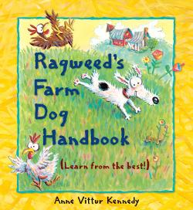 | Ragweed’s farm dog handbook, by Kennedy, Anne Vittur  From Follett  "Follow Ragweed's handy tips to become the best farm dog ever!"--Provided by publisher.
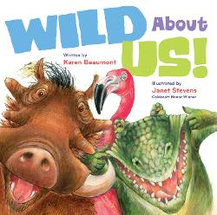 | Wild about us!, by Beaumont, Karen  From Follett  From Elephant's long nose to Kangaroo's huge feet to Monkey's stick-out ears, everyone is worth celebrating, no matter what they look like.

