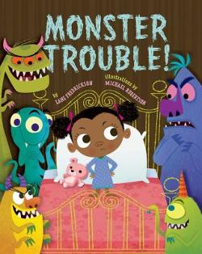 | Monster Trouble! By Fredrickson, Lane  From Follett  Although Winifred thinks the monsters who creep into her bedroom each night are cute, she cannot get any sleep and tries to scare them away.
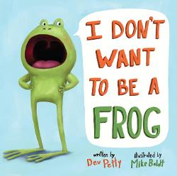 | I don’t want to be a frog! By Petty, Dev  From Follett  A frog who yearns to be any animal that is cute and warm discovers that being wet, slimy, and full of bugs has its advantages.
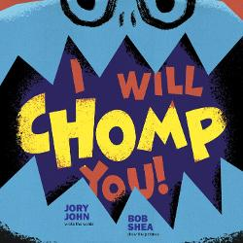 | I will chomp you! By John, Jory  From Follett  A monster tries to chomp any reader who wants to go past the first page of the book in order to keep his cakes safe.
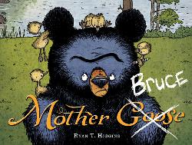 | Mother Bruce, by Higgins, Ryan T  From Follett  Title appears as Mother Goose with Goose crossed out and replaced with Bruce. "Bruce is a grumpy bear who likes no one and nothing but cooked eggs, but when some eggs he was planning to boil hatch and the goslings believe he is their mother, he must try to make the best of the situation"--Provided by publisher..
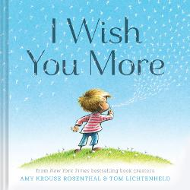  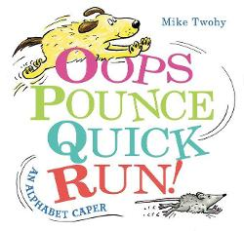 | I wish you more, by Rosenthal, Amy Krouse  From Follett  In simple text and pictures, the author and illustrator create a compendium of small daily moments.  Oops, pounce, quick, run! : an alphabet caper, by Twohy, Mike  From Follett  "When a bouncing ball wakes a sleeping mouse, it's just the beginning of an alphabet adventure"--OCLC.
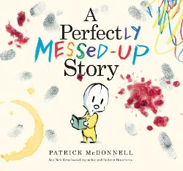 | Perfectly messed up story, A, by McDonnell, Patrick  From Follett  Louie becomes angry when the story in which he appears is ruined by messes from jelly, peanut butter, and other things that do not belong in books.
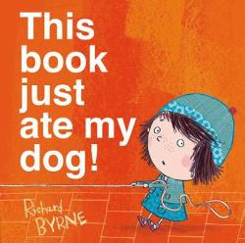 | This book just ate my dog! By Byrne, Richard  From Follett  "First published in hardcover in 2014 by Oxford University Press"--Colophon. "When her dog disappears into the gutter of the book, Bella calls for help. But when the helpers disappear too, Bella realizes it will take more than a tug on the leash to put things right"--Provided by publisher
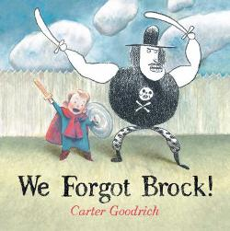 | We forgot Brock!, by Goodrich, Carter  From Follett  Phillip and Brock are best friends, although everyone else thinks Brock is imaginary, so when Phillip gets tired out at the Big Fair while Brock is still having fun, they are separated and it will take a very special twosome to bring them back together again.
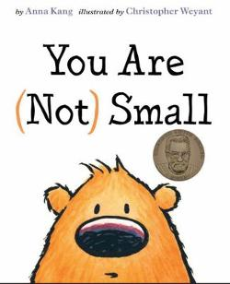 | You are (not) small, by Kang, Anna  From Follett  "Two fuzzy creatures can't agree on who is small and who is big, until a couple of surprise guests show up, settling it once and for all!"--Publisher.

